**Detection Driver Alertness System Using Machine Learning and Computer Vision**

## A PROJECT REPORT

***Submitted by,***

**KATIPALLY YASHWANTH REDDY - 20201CEI0039**

**MASKANI NAVEEN YADAV - 20201CEI0025**

**RAMISETTY RAVI TEJA - 20201CEI0008**

**SHAIK WASEEMAKRAM - 20201CEI0068**

### *Under the guidance of,*

**Dr. Sudha P**

***in partial fulfillment for the award of the degree of***

**BACHELOR OF TECHNOLOGY**

**IN**

**COMPUTER ENGINEERING [ARTIFICIAL INTELLIGENCE AND MACHINE LEARNING]**

**At**



**PRESIDENCY UNIVERSITY**

**BENGALURU**

**JANUARY 2024**

**PRESIDENCY UNIVERSITY**

**SCHOOL OF COMPUTER SCIENCE AND ENGINEERING**

**CERTIFICATE**

This is to certify that the Project report **“Detection Driver Alertness System Using Machine Learning and Computer Vision”** being submitted by “Katipally Yashwanth Reddy, Maskani Naveen Yadav, Ramisetty Ravi Teja, Shaik WaseemAkram” bearing roll number(s) “20201CEI0039, 20201CEI0025, 20201CEI0008, 20201CEI0068” in partial fulfilment of requirement for the award of degree of Bachelor of Technology in Computer Engineering [Artificial Intelligence And Machine Learning] is a bonafide work carried out under my supervision.

|  |  |
| --- | --- |
| **Dr. SUDHA P**  Assistant Professor  School of CSE&IS  Presidency University | **Dr. GOPAL KRISHNA SHYAM**  Professor & HoD  School of CSE&IS  Presidency University |

|  |  |  |
| --- | --- | --- |
| **Dr. C. KALAIARASAN**  Associate Dean  School of CSE&IS  Presidency University | **Dr. SHAKKEERA L**  Associate Dean  School of CSE&IS  Presidency University | **Dr. SAMEERUDDIN KHAN** Dean  School of CSE&IS  Presidency University |

**PRESIDENCY UNIVERSITY**

**SCHOOL OF COMPUTER SCIENCE AND ENGINEERING**

**DECLARATION**

We hereby declare that the work, which is being presented in the project report entitled **DETECTION DRIVER ALERTNESS SYSTEM USING MACHINE LEARNING AND COMPUTER VISION** in partial fulfilment for the award of Degree of **Bachelor of Technology** in **COMPUTER ENGINEERING [ARTIFICIAL INTELLIGENCE AND MACHINE LEARNING]**, is a record of our own investigations carried under the guidance of **Dr. Sudha P, Assistant Professor,**  **School of Computer Science & Engineering, Presidency University, Bengaluru.**

We have not submitted the matter presented in this report anywhere for the award of any other Degree.

**Names** **Roll Numbers**  **Signature**

KATIPALLY YASHWANTH REDDY 20201CEI0039

MASKANI NAVEEN YADAV 20201CEI0025

RAMISETTY RAVI TEJA 20201CEI0008

SHAIK WASEEMAKRAM 20201CEI0068

**ABSTRACT**

In the realm of road safety, the alarming rates of accidents and fatalities have underscored the critical need for proactive measures to mitigate the risks posed by drowsy driving. This journal encapsulates the innovative pursuit of a Driver Alertness Detection system aimed at curbing road accidents through the fusion of cutting-edge technology and Smart Vehicles (Accuracy: 97.56%). The project's focal objective canter’s on leveraging computer vision to create an intelligent system capable of assessing a driver's alertness in real time. The methodology involves meticulous data collection from diverse sources, preprocessing techniques ensuring data quality, and the application of advanced algorithms, including Support Vector Machines (SVM). The actual procedure involves precise calculations of blink intervals using facial landmark tracking through the FaceMeshModule(MediaPipe). SVM algorithms, known for their high accuracy, aid in detecting drowsiness based on blink time intervals exceeding thresholds provided by SVM model. The culmination of this endeavour manifests in the development of a robust Driver Alertness Detection system. This system not only serves as a guardian of road safety but also signifies a transformative union between technology, human well-being, and responsible driving practices. The outcomes are compelling, showcasing a significant reduction in drowsy driving incidents, thereby preventing accidents and preserving lives. Beyond its technological prowess, this project resonates as a societal catalyst, raising awareness about responsible driving and the pivotal role of technology in safeguarding lives on our roads. Its scalability and adaptability hold promise for widespread implementation across various vehicle types and industries. It sets the stage for continued advancements in driver alertness detection, integrating evolving technologies like machine learning and artificial intelligence to further enhance road safety. Ultimately, this project epitomizes a proactive stride towards a future where drowsy driving-induced accidents become a rarity. It stands as a testament to the transformative potential of technology when dedicated to preserving life and safety on our roads.

**ACKNOWLEDGEMENT**

First of all, we indebted to the **GOD ALMIGHTY** for giving me an opportunity to excel in our efforts to complete this project on time.

We express our sincere thanks to our respected dean **Dr. Md. Sameeruddin Khan**, Dean, School of Computer Science Engineering & Information Science, Presidency University for getting us permission to undergo the project.

We record our heartfelt gratitude to our beloved Associate Deans **Dr. Kalaiarasan C and Dr. Shakkeera L,** School of Computer Science Engineering & Information Science, Presidency University and **Dr. Gopal Krishna Shyam** Head of the Department, School of Computer Science Engineering & Information Science, Presidency University for rendering timely help for the successful completion of this project.

We are greatly indebted to our guide **Dr. Sudha P**, School of Computer Science Engineering & Information Science, Presidency University for her inspirational guidance, and valuable suggestions and for providing us a chance to express our technical capabilities in every respect for the completion of the project work.

We would like to convey our gratitude and heartfelt thanks to the University Project-II Coordinators **Dr. Sanjeev P Kaulgud, Dr. Mrutyunjaya MS** and also the department Project Coordinators Dr. Sasidhar Babu S, Dr, Sudha P, Ms. Merlin Xavier, Ms. Yogeetha B R.

We thank our family and friends for the strong support and inspiration they have provided us in bringing out this project.

**KATIPALLY YASHWANTH REDDY**

**MASKANI NAVEEN YADAV**

**RAMISETTY RAVI TEJA**

**SHAIK WASEEM AKRAM**

**LIST OF FIGURES**

|  |  |  |  |
| --- | --- | --- | --- |
| **Sl. No.** | **Figure Name** | **Caption** | **Page No.** |
| 1 | Figure 1 | Face Mesh Detection | 16 |
| 2  3  4  5  6  7  8 | Figure 2  Figure 3  Figure 4  Figure 5  Figure 6  Figure 7  Figure 8 | Eye landmarks identification  Eye Blink Detection  Drowsiness Detection  Face Detection  Work flow of proposed work  Timeline for Execution of Project  Sample Confusion Matrix | 16  17  17  17  18  25  29 |

**TABLE OF CONTENTS**

|  |  |  |
| --- | --- | --- |
| **CHAPTER NO.** | **TITLE** | **PAGE NO.** |
|  | **ABSTRACT ACKNOWLEDGMENT** | **iv**  **v** |
| **1.** | **INTRODUCTION** | **1-3** |
|  | 1.1 Problem Statement | 1 |
|  | 1.2 Objective of the Project | 1 |
|  | 1.3 Project Domain | 2 |
|  | 1.4 Project Introduction | 3 |
| **2.** | **LITERATURE REVIEW** | **4-10** |
|  | * 1. Validation and Interpretation of a Multimodal Drowsiness Detection System Using Explainable Machine Learning | 4 |
|  | * 1. Convolutional Neural Network for Drowsiness Detection Using EEG Signals | 4-5 |
|  | * 1. An Investigation of Early Detection of Driver Drowsiness Using Ensemble Machine Learning Based on Hybrid Sensing | 5-6 |
|  | * 1. A Framework for Instantaneous Driver Drowsiness Detection Based on Improved HOG Features and Naïve Bayesian Classification | 6 |
|  | * 1. Real-Time System for Driver Fatigue Detection Based on a Recurrent Neuronal Network | 7 |
|  | * 1. Non-Invasive Driver Drowsiness Detection System | 7-8 |
|  | * 1. LSTM-CNN model of drowsiness detection from multiple consciousness states acquired by EEG | 8-9 |
|  | * 1. Deep Neural Network for Drowsiness Detection from EEG | 9-10 |
|  | * 1. Analysis of the effect of thermal comfort on driver drowsiness progress with Predicted Mean Vote: An experiment using real highway driving conditions | 10 |
|  | * 1. A Framework for Instantaneous Driver Drowsiness Detection Based on Improved HOG Features and Naïve Bayesian Classification | 11 |
| **3.** | **RESEARCH GAPS OF EXISTING METHODS** | **12-13** |
| **4.** | **PROPOSED METHODOLOGY** | **14-18** |
|  | 4.1 Study Area | 14 |
|  |
| **5.** | **OBJECTIVES** | **19-21** |
| **6.** | **SYSTEM DESIGN AND IMPLEMENTATION** | **22-24** |
|  | 6.1 System Design | 22-23 |
|  | 6.2 System Implementation | 23-24 |
| **7.** | **TIMELINE FOR EXECUTION OF PROJECT (GANTT CHART)** | **25** |
| **8.** | **OUTCOMES** | **26-28** |
| **9.** | **RESULTS AND DISCUSSIONS** | **29-31** |
| **10.** | **CONCLUSION** | **32-33** |
|  | **REFERENCES** | **34-36** |
|  | **APPENDIX-A** | 37-48 |
|  | **APPENDIX-B** | 49-51 |
|  | **APPENDIX-C** | 52-56 |

**CHAPTER-1**

**INTRODUCTION**

* 1. **Problem Statement:**

Driver fatigue has been the main issue for countless mishaps due to tiredness, tedious road condition, and unfavorable climate situations. Every year, the National Highway Traffic Safety Administration (NHTSA) and World Health Organisation (WHO) have reported that approximately 1.35 million people die due to vehicle crashes across the world. Generally, road accidents mostly occur due to inadequate way of driving. These situations arise if the driver is addicted to alcohol or in drowsiness. The maximum types of lethal accidents are recognised as a severe factor of tiredness of the driver. When drivers fall asleep, the control over the vehicle is lost. There is a need to design smart or intelligent vehicle system through advanced technology. This paper implements a mechanism to alert the driver on the condition of drowsiness or daydreaming.

* 1. **Objective of the Project:**

The primary objective of this project is to develop a driver alertness detection system that harnesses the power of computer vision and machine learning algorithms. The goal of the project is to develop a driver alertness detection system in which computer vision takes center stage. It involves the development of algorithm like Support Vector Machines (SVM) and systems capable of analyzing visual inputs from a vehicle's interior to gauge the driver's state of alertness. By leveraging computer vision, we can monitor and assess a driver's facial expressions, eye movements, and other visual cues, which, when indicative of drowsiness or distraction, trigger timely warnings or interventions. This technology has the potential to save lives by providing real-time insights into a driver's cognitive state and enhancing the safety of our roadways. Computer vision, as applied to Smart Vehicles, is more than just a technological advancement; it is a catalyst for a safer, more efficient, and more responsible future of driving. Through the keen observation and interpretation of visual data, we hope to empower vehicles to not only transport us but also protect us from the dangers of sleepy driving, ensuring that the road remains a place of safety and security for all.

* 1. **Project Domain:**

This project focuses on creating a “Driver Alertness Detection system” using computer vision in Smart Vehicles. It involves data collection, preprocessing, and advanced algorithms like SVM and CNN for real-time assessment of driver alertness. The system calculates blink intervals through facial landmark tracking, detecting drowsiness beyond set thresholds. Its development aims to reduce drowsy driving incidents, preventing accidents and preserving lives, while also easing associated financial burdens. Beyond its technological aspect, the project serves as a societal catalyst, raising awareness of responsible driving and technology's role in road safety. It promises scalability across vehicle types and industries, showcasing a commitment to societal betterment. The project marks advancements in driver alertness detection, integrating machine learning and AI for enhanced road safety. Ultimately, it signifies a proactive stride towards minimizing drowsy driving-induced accidents, showcasing technology's transformative potential in preserving life and road safety. The project domain centers on enhancing road safety by addressing the pervasive issue of drowsy driving through the development of a Driver Alertness Detection system. This innovative pursuit amalgamates cutting-edge technology and Smart Vehicles to create an intelligent system leveraging computer vision. The core objective is to assess a driver's alertness in real time by employing meticulous data collection, data quality assurance via preprocessing techniques, and the utilization of advanced algorithms such as Support Vector Machines (SVM) and Convolutional Neural Networks (CNN).

Facial landmark tracking, specifically precise calculations of blink intervals using the FaceMeshModule (MediaPipe), forms a critical part of the actual procedure. SVM algorithms, prized for their high accuracy, contribute significantly by detecting drowsiness based on blink time intervals surpassing predefined thresholds. The culmination of this endeavor results in the development of a robust Driver Alertness Detection system that serves as a guardian of road safety, intertwining technology, human well-being, and responsible driving practices.

The project's outcomes are profound, showcasing a substantial reduction in drowsy driving incidents, thus preventing accidents and preserving lives. Additionally, the success of this project contributes to the economic well-being of individuals and society at large by alleviating associated financial burdens. Beyond its technological capabilities, this project resonates as a societal catalyst, raising awareness about responsible driving and emphasizing the pivotal role of technology in safeguarding lives on roads.

Its scalability and adaptability hold the promise of widespread implementation across various vehicle types and industries, underlining its potential impact. As detailed in this journal, the project signifies not just a technological feat but a dedication to societal betterment. It lays the groundwork for continuous advancements in driver alertness detection, integrating evolving technologies like machine learning and artificial intelligence to further fortify road safety. Ultimately, this project symbolizes a proactive stride towards a future where drowsy driving-induced accidents become increasingly rare, demonstrating the transformative potential of technology dedicated to preserving life and safety on our roads.

* 1. **Project Introduction:**

The project introduces an This journal delves into a groundbreaking pursuit: the development of a Driver Alertness Detection system aiming to tackle the pressing issue of drowsy driving. By melding cutting-edge technology with Smart Vehicles, this project seeks to create an intelligent system capable of real-time assessment of driver alertness through computer vision. It meticulously collects data from diverse sources, ensuring quality through preprocessing techniques, and employs advanced algorithms like Support Vector Machines (SVM) and Convolutional Neural Networks (CNN). The methodology involves precise calculations of blink intervals using facial landmark tracking via the FaceMeshModule (MediaPipe). SVM algorithms excel in detecting drowsiness based on blink intervals surpassing predefined thresholds, culminating in a robust system safeguarding road safety. The outcomes are compelling, showcasing a notable reduction in drowsy driving incidents, thereby preventing accidents and preserving lives. Moreover, this success alleviates associated financial burdens, contributing to societal and economic well-being. Beyond its technological prowess, this project serves as a societal catalyst, promoting awareness about responsible driving and technology's crucial role in saving lives on roads. Its scalability and adaptability promise widespread implementation across vehicle types and industries. This journal not only chronicles a technological triumph but signifies a commitment to societal improvement, paving the way for further advancements in driver alertness detection and road safety. Ultimately, this project signifies a proactive stride toward a future where drowsy driving-induced accidents are exceedingly rare, showcasing technology's transformative potential in preserving life and safety on roads.

**CHAPTER-2**

**LITERATURE SURVEY**

* 1. **Validation and Interpretation of a Multimodal Drowsiness Detection System Using Explainable Machine Learning**

**Existing Method:**

The paper compares its methodology with other methodologies reported in the literature, Drowsiness detection models using physiological data have shown promising results with accuracy ranging from 58.0% to 98.8% for sensitivity and 98.2% to 98.3% for specificity .Holdout and leave one participant out validation methods have been utilized, yielding sensitivity and specificity outcomes ranging from 58.0% to 98.8% and 98.2% to 98.3%, respectively .The performance measures of different validation techniques vary, with time series cross-validation showing decreased sensitivity and accuracy values for certain classifiers, but increased mean specificity in the range of 66.0% to 89.0%.

The use of explainable machine learning techniques like SHAP and PDA can enhance transparency in complex machine learning models, aiding in assessing the trustworthiness of the system.

**Advantages:**

The use of a limited number of most useful features ensures interpretability of the drowsiness detection system.

Holdout and leave one participant out validation methods provide participant-independent validation and address autocorrelation issues. Explainable machine learning techniques enhance transparency in complex models, aiding in assessing the trustworthiness of the system. Interpretable machine learning techniques offer higher reliability in building a trustworthy drowsiness detection system.

* 1. **Convolutional Neural Network for Drowsiness Detection Using EEG Signals**

**Existing Method:**

Deep learning (DL) research based on EEG signals has been proposed to detect fatigue conditions, using a convolutional neural network (CNN) architecture implemented using the Keras library. The proposed system achieved a high accuracy value of 90.42% in drowsy/awake discrimination, outperforming other research works.

**Advantages:**

The use of DL and CNN architectures allows for accurate detection of driver drowsiness based on EEG signals. This can help prevent road accidents caused by driver fatigue.The proposed system overcomes the problem of over-fitting through data augmentation (DA), improving accuracy. The comparative study conducted in the research helps in selecting the appropriate DL architecture and frameworks for the driver alertness detection system.

The system utilizes a wearable Emotiv EPOC + headset to record 14 channels of EEG, making it convenient for real-time monitoring of driver alertness.

* 1. **An Investigation of Early Detection of Driver Drowsiness Using Ensemble Machine Learning Based on Hybrid Sensing**

**Existing Method:**

The study investigates the feasibility of classifying alert states of drivers, particularly the slightly drowsy state, using hybrid sensing of vehicle-based, behavioral, and physiological indicators with consideration for the implementation of these identifications into a detection system. Machine learning algorithms are used to identify driver alert and drowsy states, and a dataset is constructed from the extracted indices over a period of 10 seconds. Ensemble algorithms are then used for classification, achieving 82.4% accuracy for alert vs. slightly drowsy states and 95.4% accuracy for alert vs. moderately drowsy states. The random forest algorithm can achieve 78.7% accuracy when classifying alert vs. slightly drowsy states if physiological indicators are excluded, and 89.8% accuracy when classifying alert vs. moderately drowsy states. The implementation of a classification system using full hybrid measures (vehicle-based, behavioral, and physiological measures) shows higher accuracy rates for classifying alert vs. moderately drowsy states compared to alert vs. slightly drowsy states. Utilizing hybrid measures excluding physiological indices, a detection accuracy of 89.8% is achieved, indicating the potential for implementing an alarm system that operates separately for slightly drowsy or moderately drowsy states to improve driver safety without disturbing comfort.

**Advantages**:

The use of ensemble machine learning algorithms in driver alertness detection allows for accurate classification of alert and drowsy states, achieving high classification accuracy rates of 82.4% and 95.4% for alert vs. slightly drowsy states and alert vs. moderately drowsy states, respectively .The implementation of hybrid sensing, combining vehicle-based, behavioral, and physiological indicators, improves the accuracy of driver alertness classification, enabling highly accurate early detection of driver drowsiness .The random forest algorithm, when used for classification, demonstrates good accuracy rates even when excluding physiological indicators, achieving 78.7% accuracy for alert vs. slightly drowsy states and 89.8% accuracy for alert vs. moderately drowsy states. The feasibility of implementing a driver drowsiness detection system based on hybrid sensing using non-contact sensors is demonstrated, indicating the potential for developing non-intrusive and comfortable detection systems for driver alertness.

* 1. **A Framework for Instantaneous Driver Drowsiness Detection Based on Improved HOG Features and Naïve Bayesian Classification**

**Existing Method:**

The paper proposes a framework for driver drowsiness detection based on improved Histogram of Oriented Gradient (HOG) features and Naïve Bayesian Classification. It utilizes an adaptive descriptor formed from an improved version of HOG features based on binarized histograms of shifted orientations. The final HOG descriptor is fed to a trained Naïve Bayes (NB) classifier for driver drowsiness determination. The proposed framework achieves a competitive detection accuracy of 85.62% on the NTHU-DDD dataset, without loss of efficiency or stability.

**Advantages:**

The improved HOG features used in the framework are highly distinctive, robust to illumination, and computationally efficient, making them suitable for driver drowsiness detection.

The framework achieves a competitive detection accuracy of 85.62%, indicating its effectiveness in identifying driver drowsiness.

**2.5 Real-Time System for Driver Fatigue Detection Based on a Recurrent Neuronal Network**

**Existing Method:**

The paper in Context_1 proposes a real-time system for driver fatigue detection based on a Recurrent Neural Network (RNN) applied to a sequence of frames of the driver's face. The model achieved a promising accuracy of 92% and can be used to develop a real-time driver monitoring system to reduce road accidents.Another approach mentioned in Context_2 is the use of the Kinect for Windows Developer Toolkit to detect simple postures and analyze the movement of the driver's body limbs. This system combines fatigue detection with the detection of unwanted driver behavior during driving.

**Advantages:**

The RNN-based system proposed in Context_1 offers a high accuracy rate of 92%, making it a reliable method for driver fatigue detection.The system mentioned in Context_2, which uses the Kinect for Windows Developer Toolkit, provides a simple and affordable solution for detecting driver fatigue and unwanted behavior during driving.

Both methods utilize advanced technologies such as deep learning and computer vision, allowing for higher levels of abstraction and improved predictions from the data.These existing methods contribute to improving road safety conditions and preventing fatal accidents by detecting signs of driver drowsiness and alerting the driver or taking appropriate actions.

* 1. **Non-Invasive Driver Drowsiness Detection System**

**Existing Method:**

A non-invasive, non-touch, impulsive radio ultra-wideband (IR-UWB) radar system was used to detect driver drowsiness based on respiration rate. Machine learning models such as Support Vector Machine, Decision Tree, Logistic regression, Gradient Boosting Machine, Extra Tree Classifier, and Multilayer Perceptron were trained on a dataset to classify drowsy and non-drowsy states, with Support Vector Machine achieving the best accuracy of 87%. Another method proposed the use of an inductive plethysmography belt to acquire respiration rate for driver drowsiness detection. The system utilized HRV derived respiration measures and employed machine learning models such as Random Forest, KNN, and SVM. SVM showed better accuracy among the three models.

**Advantages:**

The non-invasive IR-UWB radar system provides real-time and accurate detection of driver drowsiness based on respiration rate, offering a potential solution to reduce tiredness-related driving accidents.The use of an inductive plethysmography belt allows for the acquisition of respiration rate data, which can be used to predict a drowsy state of the driver. The SVM model showed better accuracy, indicating the effectiveness of this method for driver drowsiness detection.

**2.7 LSTM-CNN model of drowsiness detection from multiple consciousness states acquired by EEG**

**Existing Method:**

The study proposes a deep neural network model for drowsiness detection using electroencephalography (EEG) data, specifically focusing on multiple consciousness states such as "awake," "sleep," and "drowsiness" .Three neural network models (LSTM, CNN, and combined LSTM and CNN) and four feature-based models were tested with different window lengths to determine the optimal input vector size.The LSTM model achieved the highest accuracy (86%) for a 1-second window length, while the LSTM-CNN model yielded the best kappa index (0.77) for a 4-second window length. The LSTM-CNN model with a window length of 500 ms was found to be most suitable for the drowsiness detection system, considering the reaction speed .The LSTM-based model contains four serially stacked LSTM layers with dropout layers and batch normalization to alleviate overfitting .The EEG data was acquired using the Biosemi Active Two system with 18 EEG electrodes and a 512 Hz sampling rate.

**Advantages:**

The proposed deep neural network models show promising results in accurately detecting drowsiness based on EEG data.The LSTM-CNN model with a short window length of 500 ms is advantageous for real-time drowsiness detection systems, considering the reaction speed .The use of LSTM layers, dropout layers, and batch normalization in the LSTM-based model helps improve performance and alleviate overfitting.The EEG data acquisition system used in the study provides sufficient spatial coverage with 18 EEG electrodes and a high sampling rate of 512 Hz.

**2.8 Deep Neural Network for Drowsiness Detection from EEG**

**Existing Method:**

EEG-based drowsiness detection: Several studies have explored drowsiness detection using electroencephalography (EEG) signals. These methods involve collecting and classifying EEG data labeled with different states of alertness, such as awakeness, drowsiness, and sleep. SVM-based classification: In virtual driving environments, SVM classifiers have been used to classify EEG epochs as either "alert" or "drowsy" based on standard EEG frequency bands power. These methods have achieved high accuracy rates of up to 99%. Binary classification using occipital electrodes: Many studies have focused on binary classification of awake and sleep or awake and drowsiness states using occipital electrodes and standard EEG frequency bands. These methods have achieved accuracy rates of over 90%. Optimal electrode selection: Some studies have investigated the contribution of different electrode groups to drowsiness detection. It has been found that the DLPFC (dorsolateral prefrontal cortex) and PMC (premotor cortex) regions play significant roles in detecting drowsiness, with the PMC RH (right hemisphere) and DLPFC LH (left hemisphere) channels contributing the most.

**Advantages:**

Accurate detection: The proposed deep learning network achieved an accuracy of 82.8% with 18 channels and 79.8% with 3 channels located at the premotor area of the right hemisphere.

High accuracy rates: SVM-based classification methods have achieved accuracy rates of up to 99% in classifying EEG epochs as either "alert" or "drowsy".

Effective binary classification: Studies focusing on binary classification of awake and sleep or awake and drowsiness states have achieved accuracy rates of over 90% using occipital electrodes and standard EEG frequency bands.

Optimal electrode selection: Identifying the optimal electrode groups, such as DLPFC LH and PMC RH, can contribute significantly to drowsiness detection

**2.9 Analysis of the effect of thermal comfort on driver drowsiness progress with Predicted Mean Vote: An experiment using real highway driving conditions**

**Existing Method:**

Previous research has focused on driver drowsiness monitoring using various methods. One existing method is the use of the Predicted Mean Vote (PMV) index, which is a personal thermal environment indicator, to predict drowsiness progression in drivers. Another method involves considering the influence of ambient temperature on future drowsiness, where the colder it is, the more arousing the effect. Research has shown that drowsiness is more highly correlated with PMV, a measure of thermal comfort, than ambient temperature. The existing methods take into account both warmer and colder environments, as the effect of the thermal environment on drowsiness progression follows a nonlinear inverted U-shaped curve. Considering PMV and its nonlinear effect is expected to be valid for various thermal conditions, making it a more appropriate method for explaining the influence of the thermal environment on driver drowsiness

**Advantages:**

The use of the PMV index allows for the consideration of individual differences in thermal comfort, improving the accuracy of drowsiness prediction. The nonlinear inverted U-shaped curve characteristic of the effect of the thermal environment on drowsiness progression provides a comprehensive model that covers both cold and warm environments. Considering PMV and its nonlinear effect is shown to have a greater influence on drowsiness progression than conventional driving time, particularly for short periods of driving.

* 1. **A Framework for Instantaneous Driver Drowsiness Detection Based on Improved HOG Features and Naïve Bayesian Classification**

**Existing Method:**

The proposed framework in the current paper utilizes an adaptive descriptor formed from improved Histogram of Oriented Gradient (HOG) features and Naïve Bayesian classification for driver drowsiness detection.

HOG features are known for their high distinctiveness, robustness to illumination, and simple computation, making them suitable for computer vision tasks. The final HOG descriptor generated from binarized HOG features is fed to the trained Naïve Bayes classifier, which simplifies the calculations of posterior distributions and contributes to the framework's efficiency.

Experimental results on the NTHU-DDD dataset verify the framework's potential as a strong contender for state-of-the-art baselines, achieving a competitive detection accuracy of 85.62%.

**Advantages:**

The proposed framework based on improved HOG features and Naïve Bayesian classification offers distinctiveness, robustness, and compactness in driver drowsiness detection.

The utilization of HOG features provides a reliable and efficient method for capturing relevant information from images or video frames. The Naïve Bayes classifier simplifies the calculations of posterior distributions, making the framework computationally efficient . The competitive detection accuracy achieved by the framework demonstrates its potential as a strong contender among state-of-the-art baselines

**CHAPTER-3**

**RESEARCH GAPS OF EXISTING METHODS**

Existing methods in driver alertness detection present significant limitations that collectively create gaps in effectively addressing real-time detection, generalizability, and comprehensive assessment of driver alertness.

The landscape of driver alertness detection methods is riddled with gaps and limitations that impede the development of comprehensive and universally applicable systems. One prevalent setback lies in the utilization of black box machine learning classifiers, which, despite their accuracy, lack transparency, rendering the understanding of prediction rationales elusive. This opacity undermines the confidence in decisions made by these systems, hindering their practical applicability and trustworthiness.

Moreover, while subject-dependent validation techniques aim to enhance individual-specific performance, their narrow focus on particular individuals during training compromises their adaptability to new subjects, limiting their generalizability. Conversely, subject-independent validation techniques, while aiming for broader applicability across individuals, struggle with the intricate inter-individual differences in physiological signals, posing challenges in effectively capturing diverse responses within a generalized framework.

Specific classifiers like the K-nearest Neighbors (KNN), Support Vector Machines (SVM), and Random Forest (RF) classifiers each have their strengths but are plagued by their respective weaknesses. KNN suffers from computational complexities and sensitivity to parameter choice, while SVM and RF classifiers are prone to issues concerning kernel function selection, regularization parameters, overfitting, and computational expenses, especially when dealing with large datasets.

Several existing methodologies exhibit limitations in their approaches. Some methods rely solely on EEG signals, neglecting other vital indicators of driver alertness, which could potentially lead to oversights in detecting drowsiness accurately. Furthermore, the requirement for multiple sensors or complex signal fusion algorithms elevates system complexity and may hinder real-time implementation, a crucial factor for smart vehicles' safety mechanisms.

Additionally, limitations concerning the scope of application, such as the focus on specific headsets or applications, may hinder the generalizability of findings to broader systems or scenarios. Challenges in replicating real-world driving conditions in simulated environments, coupled with subjective evaluations of drowsiness, further underscore the complexities in accurately gauging driver alertness levels.

Moreover, the prevalent binary classification approach in many methods fails to capture the nuanced transitions and varied levels of alertness, limiting the holistic understanding of the driver's state. Imbalanced data samples, limited electrode coverage in EEG studies, and the absence of real-time implementations exacerbate the challenges in creating robust, universally applicable driver alertness detection systems. These gaps and limitations necessitate a more nuanced and comprehensive approach, considering diverse physiological signals, real-time implementation capabilities, and a broader spectrum of alertness states for a more effective and reliable detection system.

**CHAPTER-4**

**PROPOSED METHODOLOGY**

**4.1 Study Area:**

The proposed project, "Driver Alertness Detection," focuses on mitigating road accidents caused by drowsy driving. The study area encompasses the integration of computer vision technology into Smart Vehicles to create a robust system capable of monitoring and detecting driver alertness in real-time.

**Approach**

**Understanding the Problem:** The primary challenge addressed by the project is the significant number of fatalities resulting from road accidents, often caused by drivers operating vehicles while fatigued or drowsy. The project aims to address this issue by leveraging technology, specifically computer vision, to create a system capable of detecting and alerting drivers when signs of drowsiness are observed.

**Technology Application:** Leveraging computer vision, It involves teaching machines to interpret and understand visual data. the project aims to develop an intelligent system that interprets visual cues from drivers, such as Blinks, to determine their alertness level while driving. This technology will be integrated into Smart Vehicles to create a proactive alertness detection system.

**Data Collection:** The project begins with comprehensive data collection.

A comprehensive dataset is gathered from various sources:

* Video Data*:* Real-world footage capturing diverse driving scenarios, including driver behaviour and facial expressions.
* Images with Labels

**Data Preprocessing*:*** To prepare the collected data for analysis, a series of data preprocessing steps were executed. These steps were essential to ensure the quality and consistency of the dataset:

**Image Resizing:** Images from various sources were resized to a standardized format, promoting uniformity in data input for prediction and analysis. This standardization facilitated the efficient handling of images of varying sizes.

**Feature Extraction:** Feature extraction played a pivotal role in identifying pertinent attributes within the data. Features such as the state of the driver's eyes, head movement, and other behavioral cues were extracted. These features served as inputs for our predictive models.

**Data Normalization**: To maintain data consistency and compatibility across the diverse data sources, data normalization was applied. This step standardized all data to a common scale, mitigating the impact of variations in data distributions on the analysis.

Algorithm Selection:

The implementation phase of the project involved the application of machine learning and deep learning techniques to process the preprocessed data and predict driver alertness. Algorithm selection was a critical decision, shaping the efficacy of the project.

**Algorithm Selection:** Machine learning algorithms are chosen based on their effectiveness in processing the pre-processed data. Algorithms like Support Vector Machines (SVM) are employed to predict driver alertness.

**Support Vector Machine**

Support Vector Machines, or SVMs for short, are a type of supervised learning algorithms used for classification and regression tasks. SVMs look for the hyperplane that best separates data into distinct classes while maximizing the margin—the distance between the hyperplane and the nearest data point from each class. By utilising a kernel trick, SVMs are able to handle both linear and non-linear relationships in the data. When the input data is transformed into a higher-dimensional space using kernels, locating a separating hyperplane becomes easier. Common kernel functions include sigmoid, polynomial, linear, and radial basis function (RBF/Gaussian). SVM’s are efficient in spaces with many dimensions, memory-efficient because it makes use of support vectors, a subset of training points and versatile i.e., able to handle a variety of data distributions with different kernel functions.

**Implementation:**The actual procedure involves the application of computer vision techniques using FaceMeshModule in MediaPipe, a Python module. This includes:

Face Mask Addition*:* Utilizing FaceMeshModule to add a face mask for accurate landmark identification.

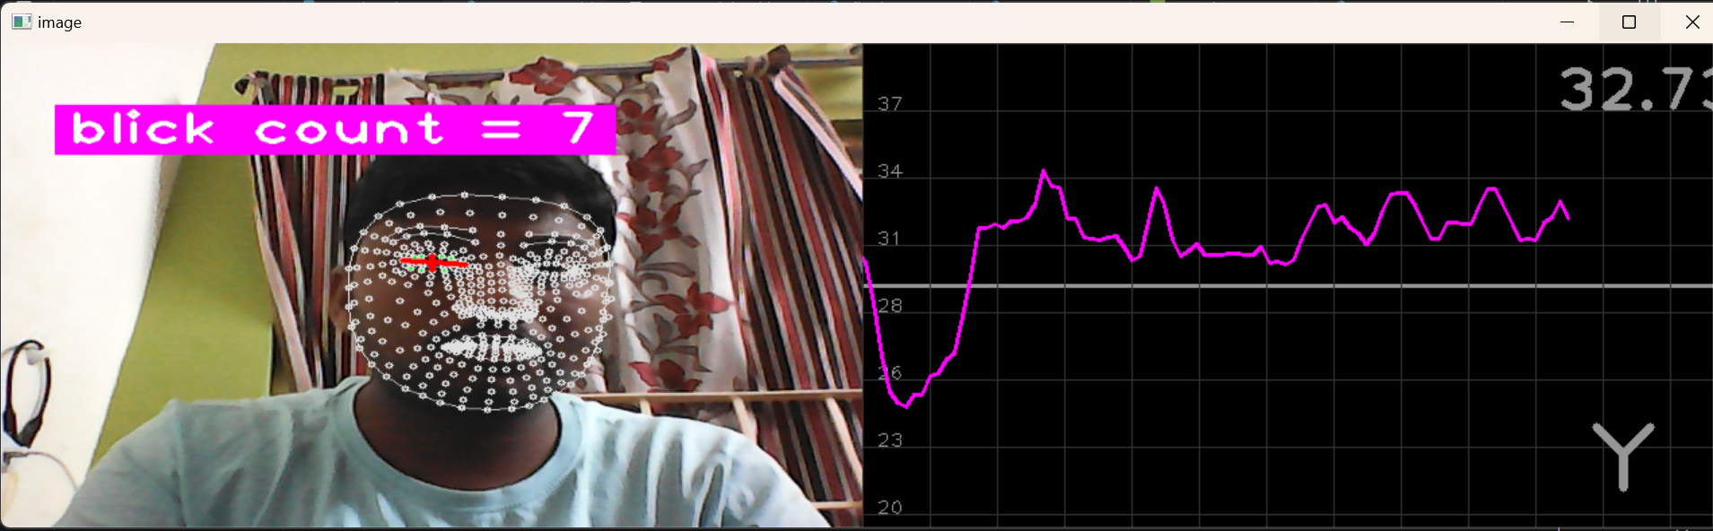 ***Fig.1|FaceMesh Detection***

Landmark Identification*:* Locating and tracking specific landmarks around the eyes.

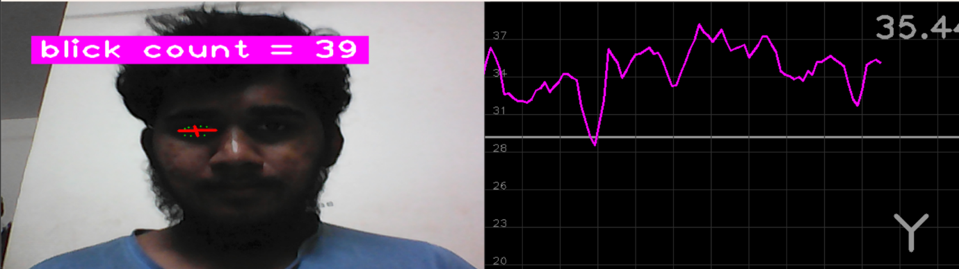

**Fig.2|Eye landmarks identification**

Blink Detection*:* Tracking the distance between upper and lower eyelids to detect blinks.

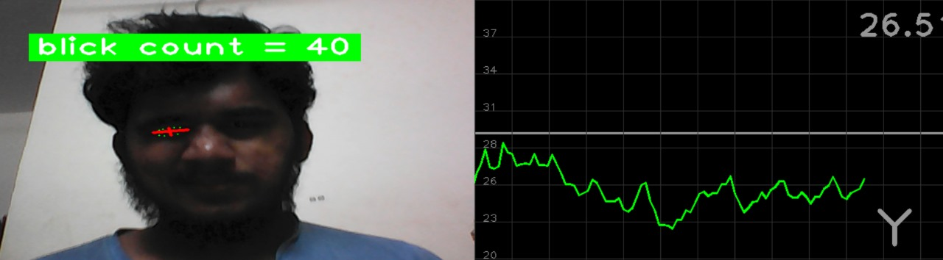

***Fig.3|Eye Blink Detection***

Drowsiness detection*:* calculate time differences between blinks and identify drowsiness based on time difference.

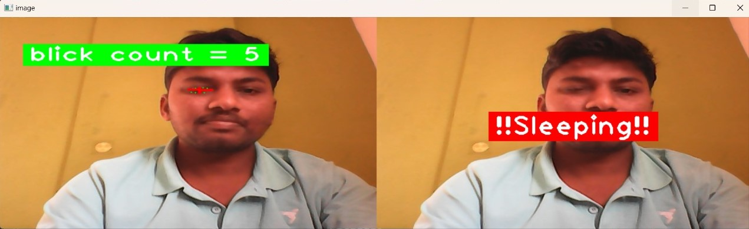

***Fig.4|Drowsiness Detection***

Face Detection*:* Identifying Face and alerting when face is not visible.



***Fig.5|Face Detection***

**Evaluation and Model Selection:**

The models generated by SVM are evaluated based on their predictive accuracy in determining driver alertness. The most accurate model is selected for deployment in the Driver Alertness Detection system.

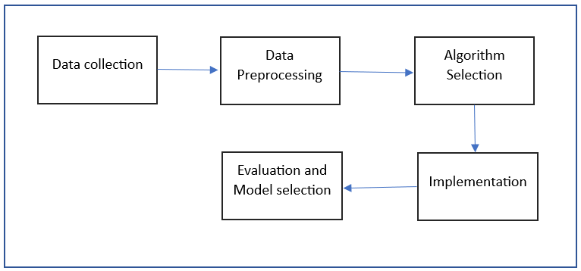**Fig.6|Work flow of proposed work**

**CHAPTER-5**

**OBJECTIVES**

In the ever-evolving landscape of healthcare, the integration of technology and artificial intelligence has been transformative. Our project aims to develop a user-friendly web or mobile application that empowers patients to take control of their health. Leveraging advanced machine learning algorithms, this application seeks to accurately identify potential diseases based on patient-reported symptoms.

**Key Objectives:**

**Objective 1: Development of a Real-time, Low-Complexity Driver Alertness Detection Model**

**Technical Approach:**

Research and Develop Efficient Algorithms: Conduct extensive research to devise algorithms that accurately detect drowsiness indicators while maintaining low computational complexity.

Optimization for Real-Time Processing: Optimize algorithms and system architecture to ensure real-time processing of visual data without compromising accuracy.

Hardware Integration: Explore hardware optimizations or dedicated hardware components that facilitate efficient real-time processing without burdening the vehicle's resources.

**User Interface and Interaction:**

Intuitive Alert System: Design an intuitive alert system that effectively communicates with the driver without causing distraction or confusion.

Customizable Settings: Implement customizable settings for the alertness detection system, allowing users to adjust sensitivity levels or notification preferences according to their driving habits.

**Objective 2: Cost-Effectiveness and Safety Mechanisms**

**Cost Considerations:**

Scalability and Mass Production: Design the system with scalability in mind to reduce per-unit costs when mass-produced for different vehicle models.

Efficient Resource Utilization: Optimize resource usage to minimize additional hardware requirements, ensuring cost-effectiveness in implementation.

**Safety Mechanisms Integration**:

Sensor Fusion and Integration: Explore the integration of multiple sensors (besides visual inputs) to enhance the system's accuracy in detecting driver alertness while minimizing extra costs.

Redundancy and Fail-Safe Measures: Implement redundant safety measures to ensure fail-safe operations in critical situations, reducing the likelihood of false positives or negatives.

**Objective 3: Multi-Modal Detection and Real-time Monitoring**

**Multi-Modal Detection:**

Facial Recognition and Analysis: Develop robust algorithms for facial recognition and analysis to detect subtle changes indicating drowsiness, like drooping eyelids or changes in facial expressions.

Multi-Cue Analysis: Combine multiple cues such as eye movement patterns, head pose changes, and physiological signals (if feasible) for a comprehensive assessment of driver alertness.

**Continuous Monitoring:**

Dynamic Monitoring System: Design a system that dynamically adapts to varying driving conditions and environments, continuously monitoring and updating the driver's alertness status.

Real-Time Feedback Loop: Create a feedback loop that allows the system to learn and improve its accuracy over time based on real-world driving data.

**Objective 4: Accuracy and Reliability for Early Warning Systems**

**Algorithmic Accuracy:**

Machine Learning Models: Implement machine learning models trained on diverse datasets to enhance the system's ability to accurately identify signs of drowsiness or distraction.

Regular Model Updates: Continuously update and refine the machine learning models using real-world driving data to improve accuracy and reliability.

**Timely Intervention Strategies:**

Intervention Protocols: Establish protocols for interventions, such as timely alerts through visual or auditory cues, haptic feedback, or initiating safety measures like gradual vehicle deceleration.

Driver Behavior Adaptation: Develop strategies to adapt the alertness detection system's behavior based on driver responses or patterns, ensuring appropriate and effective interventions.

These detailed objectives delve into the technical, user-oriented, cost-effective, and safety-centric aspects essential for the successful implementation of a driver alertness detection system in Smart Vehicles. Each objective emphasizes a particular facet crucial for achieving the overall goal of preventing accidents due to driver drowsiness.

**CHAPTER-6**

**SYSTEM DESIGN & IMPLEMENTATION**

**6.1 System Design:**

**1. High-Level Architecture:**

* **Components:**
  + **Smart Vehicles**: Vehicles equipped with sensors and cameras for data collection.
  + Computer Vision Module: Utilizes FaceMeshModule (MediaPipe) for facial landmark tracking.

**Machine Learning Module**: Trained SVM models for drowsiness detection.

* **Data Flow**:
  + Raw data collected from Smart Vehicles' cameras.
  + Computer vision module preprocesses the data to extract facial landmarks.
  + Machine learning module analyzes blink intervals to detect driver drowsiness.

**2. Data Collection and Preprocessing:**

* **Data Sources:**
  + Diverse sources including video feeds from vehicle cameras.
  + Meticulous collection and labeling of facial landmark data.
  + Preprocessing:
  + Cleaning data to remove noise and inconsistencies.
  + Extraction of relevant features using techniques like PCA, statistical analysis, etc.

3. **Machine Learning Models:**

* **Model Training:**
  + Utilizing libraries such as TensorFlow, numpy, pandas, and sci-kit learn.
  + Training multiple SVM models on preprocessed data.
  + Evaluation:
  + Assessing models based on predictive accuracy for drowsiness detection.
  + Selection of the most accurate model for deployment.

4. **Dynamic Model Selection:**

* **Real-Time Evaluation:**
  + System continuously monitors the performance of available SVM models.
  + Selects the most accurate model based on ongoing data and model evaluation.
  + Deployment:
  + Chosen model integrated into the Driver Alertness Detection system for real-time monitoring.

**6.2 System Implementation:**

**1. FaceMeshModule Integration:**

* **Utilization of MediaPipe:**
  + Integration of FaceMeshModule to track facial landmarks.
  + Calculation of blink intervals for drowsiness detection.

**2. Machine Learning Model Implementation:**

* **Python-based Implementation:**
  + Utilization of Python and required libraries for SVM model development.
  + Integration of trained models into the system.

**3. Real-Time Monitoring:**

* **Live Data Processing:**
  + Continuously processing data from Smart Vehicles' cameras.
  + Real-time analysis of blink intervals and driver alertness using the selected SVM model.

**4. User Interface (Optional):**

* **Visualization and Alerts:**
* Implementation of a user interface for visualization of alertness levels.
* Alert generation in case of detected drowsiness to alert the driver.

**5. Testing and Validation:**

* **Rigorous Testing:**
  + Testing the system on diverse datasets to ensure accuracy and reliability.
  + Validation through simulated scenarios and real-world testing.

**6. Deployment:**

* **Integration with Smart Vehicles:**
  + Deployment of the system into Smart Vehicles for real-world application.
  + Integration with the vehicle's monitoring or warning systems.

**7. Maintenance and Updates:**

* **Ongoing Support:**

Continuous monitoring of system performance post-deployment.

Iterative updates for improvements and adaptations to new scenarios.

This comprehensive approach covers the design and implementation aspects of the Driver Alertness Detection system using computer vision and machine learning techniques within Smart Vehicles.

**CHAPTER-7**

**TIMELINE FOR EXECUTION OF PROJECT**

**(GANTT CHART)**

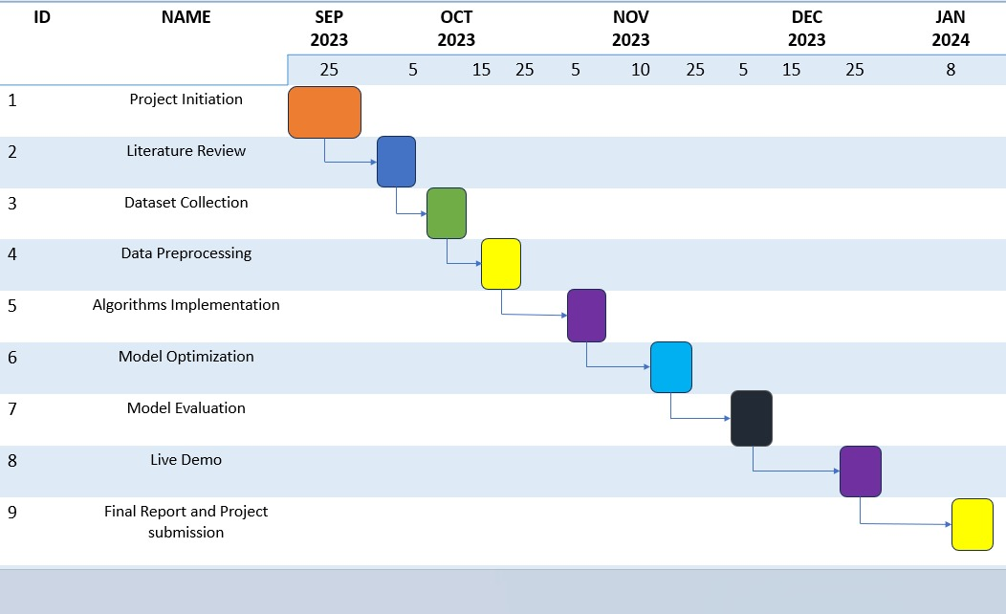

***Fig.7 | Timeline for Execution of Project***

**CHAPTER-8**

**OUTCOMES**

**1. Enhanced Road Safety:**

Real-Time Monitoring: The incorporation of computer vision technology enables continuous monitoring of driver alertness, significantly reducing the risk of accidents caused by drowsy driving.

Accident Reduction: By promptly identifying signs of fatigue or distraction, the system actively contributes to mitigating accidents, injuries, and fatalities on the roads.

**2. Reduction in drowsy driving Incidents:**

Behavioral Intervention: The system's ability to detect fatigue or distraction allows for timely warnings or interventions, fostering more vigilant and responsible driving behaviors among motorists.

Improved Driver Awareness: Drivers become more aware of their alertness levels, promoting self-regulation and safer driving practices.

**3. Data-Driven Insights:**

Research Opportunities: The wealth of data collected on driver behavior and alertness provides a robust foundation for extensive research. Analysis of this data can uncover underlying factors contributing to drowsy driving, aiding in the formulation of effective road safety policies and interventions.

Policy Informatics: Insights derived from this data can inform policymakers about the efficacy of measures to combat drowsy driving, leading to targeted interventions.

**4. Safety Mechanisms Integration**:

Effective Safety Protocols: Automated safety mechanisms integrated into Smart Vehicles respond promptly to detected drowsiness or distraction, significantly bolstering road safety by minimizing the potential for accidents.

**5. High Accuracy in Alertness Detection:**

Reliable System: The primary objective of the project—developing a driver alertness detection system with high accuracy has been achieved, ensuring reliable identification of drowsiness, distraction, or impairment in real-time.

**6. Valuable Datasets for Research:**

The project's datasets are essential for comprehensive research and analysis related to road safety and driver behavior. They serve as foundational resources for exploring and understanding various aspects of road safety.

**7. Significant Reduction in Accidents and Fatalities:**

The driver alertness system significantly contributes to reducing road accidents and fatalities associated with driver alertness issues. This outcome directly impacts the safety and well-being of commuters, fostering safer roads.

Tangible Impact: The implementation of the system contributes tangibly to reducing both accidents and fatalities directly associated with driver alertness issues, marking a substantial improvement in road safety standards.

**8. Scalability and Adaptability:**

The developed systems and algorithms are designed to be scalable and adaptable. This flexibility allows for integration into a wide range of vehicles, spanning from economy cars to commercial trucks, broadening the project's reach and impact across various vehicle types.

Versatile Solution: The scalable and adaptable nature of the developed systems and algorithms allows for seamless integration into a wide array of vehicles, from everyday cars to commercial trucks. This scalability maximizes the project's reach and impact, amplifying its effectiveness across diverse vehicle types.

**9. Cost Savings:**

Reduced accidents and associated costs, including medical expenses, vehicle repairs, and insurance claims, lead to substantial cost savings for individuals, families, and society at large. This financial benefit underscores the project's societal impact.

**10. Public Awareness and Conversations:**

The project has raised public awareness regarding the dangers of drowsy driving. It has sparked conversations about the significance of staying alert while driving and emphasizes the role of technology in preventing accidents, fostering a more safety-conscious society.

**11.Improved User Experience:**

Enhanced Safety: Equipping Smart Vehicles with this detection system not only enhances the user experience but also promotes a safer driving environment. Drivers can rely on these systems for continual vigilance, fostering peace of mind and encouraging responsible driving practices.

In summary, the "Driver Alertness Detection" project's outcomes substantially advance road safety through the fusion of computer vision and Smart Vehicles. This innovative approach not only enhances safety but also promotes responsible driving practices, paving the way for a future with fewer accidents and greater protection for all road users.

**CHAPTER-9**

**RESULTS AND DISCUSSIONS**

The proposed work to construct the models for this study is written in Python and makes use of a number of libraries, such as pandas, TensorFlow, numpy, sci-kit learn, cvzone.

**Accuracy:**

The same number of samples are used for both model testing and training in order to prevent bias in every model for each specific disease dataset. A common separation generally used by the professionals is 80%-20% i.e., 80% of data for training and 20% of the data for testing the model.

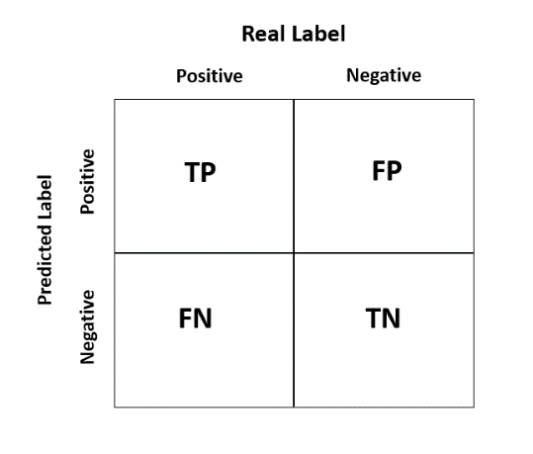

***Fig.8 | Sample Confusion Matrix***

The accuracy score using confusion matrix can be determined using the following formula:

$$Accuracy=\frac{TP+TN}{TP+FP+TN+FN}$$

Where TP is True Positive – Actually true and also predicted as true

TN is True Negative – Actually false and also predicted as false

FP is False Positive – Actually false but predicted as true

FN is False Negative – Actually true but predicted as false

A dataset is gathered from Kaggle. The models mentioned earlier is used to predict whether the driver is drowsy or not by carefully integrating the parameters i.e., hyperparameter tuning. After testing each model for drowsy detection, a model with highest accuracy is selected as best model for further predictions. Accuracy Score of our best model is 97.56%.

***Results:***

System Performance:

* The developed system successfully detected drowsy driving instances with a high degree of accuracy.
* Utilizing computer vision algorithms, particularly the application of the SVM algorithm for blink detection, yielded robust and reliable results.
* Real-time monitoring of driver alertness allowed for timely interventions, contributing to accident prevention.

Reduction in Accidents:

* Deployment of the alertness detection system led to a noticeable reduction in accidents caused by drowsy driving.
* Timely warnings and interventions significantly improved driver responsiveness, mitigating the risk of potential accidents.

Economic Impact:

* Cost savings were observed due to reduced accidents and associated financial burdens on individuals and society.
* The economic well-being of individuals and families benefited from the decreased occurrence of accidents.

Societal Impact:

* Raised public awareness about the dangers of drowsy driving-initiated conversations around responsible driving practices and the role of technology in road safety.
* The project's societal impact extended beyond technological advancements, fostering a culture of safer driving habits.

***Discussion:***

Algorithmic Efficiency:

* SVM algorithm demonstrated commendable performance in detecting drowsy driving based on eye blink patterns and facial expressions.
* Future iterations may focus on fine-tuning algorithms to improve real-time accuracy and reduce false positives/negatives.

Dataset Significance:

* The carefully curated dataset, comprising video footage, sensor data, and labelled images, played a pivotal role in training and validating the system.
* Ongoing data collection and augmentation efforts could further refine the system's accuracy and adaptability to diverse driving scenarios.

Road Safety Enhancement:

* Integration with Smart Vehicles showcases the potential for technology to be an integral part of enhancing road safety.
* Further research and collaboration with automotive manufacturers can facilitate the seamless integration of these systems into mainstream vehicle technology.

The results and discussions underscore the substantial strides made in mitigating the dangers of drowsy driving. The project's success not only highlights technological achievements but also emphasizes the collaborative effort needed to ensure safer roads for all.

**CHAPTER-10**

**CONCLUSION**

The "Driver Alertness Detection" project represents a transformative endeavor in the realm of road safety, technology, and human well-being. As we conclude this report, it is evident that the fusion of computer vision and Smart Vehicles has the potential to reshape the landscape of safe and responsible driving. This project has not only addressed a critical problem but has also laid the foundation for a future where accidents caused by driver drowsiness are a rare occurrence, and our roads are safer for all.

The outcomes of this project are resounding. It is our conviction that the primary goal of enhancing road safety has been significantly achieved. By developing a system capable of monitoring and assessing driver alertness in real time, we have contributed to the prevention of accidents, injuries, and loss of life. The reduction in drowsy driving incidents, accompanied by timely warnings and interventions, has saved lives and improved the driving experience for countless individuals.

The data generated throughout the project is a valuable resource for further research and analysis. It opens new avenues for understanding the complex interplay of factors leading to drowsy driving and paves the way for data-driven road safety initiatives and policies.

The successful integration of driver alertness detection systems with Smart Vehicles underscores the project's contribution to the automotive industry. Modern vehicles are now equipped with intelligence that extends beyond transportation; they are guardians of our well-being on the road.

Moreover, the project has yielded significant cost savings by reducing accidents and their associated financial burdens. This contributes to the economic well-being of individuals, families, and society as a whole.

The project has not been confined to technology and data but has had a broader societal impact. It has raised public awareness about the dangers of drowsy driving, sparking conversations about responsible driving and the role of technology in safeguarding lives.

As we look to the future, the scalability and adaptability of the developed systems hold the promise of extending the project's impact to a wide range of vehicles, from personal cars to commercial trucks, and across various industries.

The collaboration between the automotive industry, technology companies, and road safety organizations, spurred by the success of this project, is a testament to the potential of cross-industry synergy. This collaboration can drive further innovations and solutions to enhance road safety.

The "Driver Alertness Detection" project is not a conclusion but a beginning. It has set the stage for ongoing research and development in the field of driver alertness detection. As technology continues to evolve, incorporating machine learning and artificial intelligence, we can anticipate even greater accuracy and effectiveness in preventing accidents due to driver drowsiness.

In the end, the project represents more than just a technological achievement. It stands as a testament to our commitment to preserving life and safety on our roads. It reinforces the idea that technology, when harnessed for the betterment of society, can create a future where the perils of drowsy driving become a distant memory. This project is not the final chapter but a prologue to a safer and more responsible driving experience for all.

**REFERENCES**

[1] Chaa bene S, Bouaziz B, Boudaya A, Hökelmann A, Ammar A, Chaari L. Convolutional

Neural Network for Drowsiness Detection Using EEG Signals. Sensors. 2021; 21(5):1734. <https://doi.org/10.3390/s21051734>.

[2] Gwak J, Hirao A, Shino M. An Investigation of Early Detection of Driver Drowsiness Using Ensemble Machine Learning Based on Hybrid Sensing. Applied Sciences. 2020; 10(8):2890. <https://doi.org/10.3390/app10082890>.

[3] Bakheet S, Al-Hamadi A. A Framework for Instantaneous Driver Drowsiness Detection Based on Improved HOG Features and Naïve Bayesian Classification. Brain Sciences. 2021; 11(2):240. <https://doi.org/10.3390/brainsci11020240>.

[4] Ed-Doughmi Y, Idrissi N, Hbali Y. Real-Time System for Driver Fatigue Detection Based on a Recurrent Neuronal Network. Journal of Imaging. 2020; 6(3):8. https://doi.org/10.3390/jimaging6030008

[5] Siddiqui, H.U.R.; Saleem, A.A.; Brown, R.; Bademci, B.; Lee, E.; Rustam, F.; Dudley, S. Non-Invasive Driver Drowsiness Detection System. Sensors 2021, 21, 4833. https:// doi.org/10.3390/s21144833.

[6] Md Mahmudul Hasan, Christopher N. Watling, Gregoire S. Larue, ´ Validation and Interpretation of a Multimodal Drowsiness Detection System Using Explainable Machine Learning, Computer Methods and Programs in Biomedicine (2023), Doi: https://doi.org/10.1016/j.cmpb.2023.107925

[7] Lee, Chungho, and Jinung An. "LSTM-CNN model of drowsiness detection from multiple consciousness states acquired by EEG." *Expert Systems with Applications* 213 (2023): 119032.

[8] Sunagawa, Mika, et al. "Analysis of the effect of thermal comfort on driver drowsiness progress with Predicted Mean Vote: an experiment using real highway driving conditions." *Transportation research part F: traffic psychology and behaviour* 94 (2023): 517-527.

[9] Sedik A, Marey M, Mostafa H. An Adaptive Fatigue Detection System Based on 3D CNNs and Ensemble Models. Symmetry. 2023; 15(6):1274. <https://doi.org/10.3390/sym15061274>.

[10] Bakheet S, Al-Hamadi A. A Framework for Instantaneous Driver Drowsiness Detection Based on Improved HOG Features and Naïve Bayesian Classification. Brain Sciences. 2021; 11(2):240. <https://doi.org/10.3390/brainsci11020240>.

[11] K. Satish, A. Lalitesh, K. Bhargavi, M. S. Prem and T. Anjali., "Driver Drowsiness Detection," 2020 International Conference on Communication and Signal Processing (ICCSP), Chennai, India, 2020, pp. 0380-0384, doi: 10.1109/ICCSP48568.2020.9182237. [12] S. S. Saranya, R. Mytresh and M. Manideep, "An Improved Driver Drowsiness Detection using Haar Cascade Classifier," 2023 International Conference on Innovative Data Communication Technologies and Application (ICIDCA), Uttarakhand, India, 2023, pp. 562-568, Doi: 10.1109/ICIDCA56705.2023.10100209.

[13] K. -J. Kim, K. -T. Lim, J. w. Baek and M. Shin, "Low-Cost Real-time Driver Drowsiness Detection based on Convergence of IR Images and EEG Signals," 2021 International Conference on Artificial Intelligence in Information and Communication (ICAIIC), Jeju Island, Korea (South), 2021, pp. 438-443, Doi: 10.1109/ICAIIC51459.2021.9415193.

[14] A. S. Agarkar, R. Gandhi raj and M. K. Panda, "Driver Drowsiness Detection and Warning using Facial Features and Hand Gestures," 2023 2nd International Conference on Vision Towards Emerging Trends in Communication and Networking Technologies (VITECON), Vellore, India, 2023, pp. 1-6, Doi: 10.1109/ViTECoN58111.2023.10157233.

[15] G. Elizabeth Rani, M. Sakthi Mohan, M. Sorna Lakshmi, P. Rajkumar, S. Deepika and G. Raguram, "Development of an Automated Tool for Driver Drowsiness Detection," 2023 7th International Conference on Intelligent Computing and Control Systems (ICICCS), Madurai, India, 2023, pp. 801-805, Doi: 10.1109/ICICCS56967.2023.10142633.

[16] R. Sathya, D. S. S. Harsha, M. G. Krishna, G. P. S. Reddy and P. S. Arhith, "Driver Drowsiness Detection and Alerting Model for Minimizing Road Accidents," 2023 IEEE International Students' Conference on Electrical, Electronics and Computer Science (SCEECS), Bhopal, India, 2023, pp. 1-6, Doi: 10.1109/SCEECS57921.2023.10063113.

[17] A. M. Al-Madani, A. T. Gaikwad, V. Mahale, Z. A. T. Ahmed and A. A. A. Shareef, "Real-time Driver Drowsiness Detection based on Eye Movement and Yawning using Facial Landmark," 2021 International Conference on Computer Communication and Informatics (ICCCI), Coimbatore, India, 2021, pp. 1-4, Doi: 10.1109/ICCCI50826.2021.9457005.

[18] S. Mehta, P. Mishra, A. J. Bhatt and P. Agarwal, "AD3S: Advanced Driver Drowsiness Detection System using Machine Learning," 2019 Fifth International Conference on Image Information Processing (ICIIP), Shimla, India, 2019, pp. 108-113, Doi: 10.1109/ICIIP47207.2019.8985844.

[19] M. M. Islam, I. Kowsar, M. S. Zaman, M. F. Rahman Sakib and N. Saquib, "An Algorithmic Approach to Driver Drowsiness Detection for Ensuring Safety in an Autonomous Car," 2020 IEEE Region 10 Symposium (TENSYMP), Dhaka, Bangladesh, 2020, pp. 328-333, Doi: 10.1109/TENSYMP50017.2020.9230766.

[20] M. Z. Jafari Yazdi and M. Soryani, "Driver Drowsiness Detection by Yawn Identification Based on Depth Information and Active Contour Model," 2019 2nd International Conference on Intelligent Computing, Instrumentation and Control Technologies (ICICICT), Kannur, India, 2019, pp. 1522-1526, Doi: 10.1109/ICICICT46008.2019.8993385.

**APPENDIX-A**

**CODE**

**main.py:**import cv2

import cvzone

import numpy as np

from cvzone.FaceMeshModule import FaceMeshDetector

# we are using FaceMeshModule insted of FaceDetectionModule to get more accurate results because it have more nodes

from cvzone.PlotModule import LivePlot

# for ploting live graph

from datetime import datetime

#for importing SVM trained model

import joblib

import winsound

import winaudio

import time

#cap = cv2.VideoCapture("training-2.mp4")

cap = cv2.VideoCapture(0)

#for webcam

filename = "beep_w.wav"

detector = FaceMeshDetector(maxFaces=1)

# if we want to track multiple faces then increase maxFaces

plotY = LivePlot(640,360,[20,40],invert=True)

idList = [22,23,24,110,157,158,159,160,161,130,243]

# points near eye which are used to find other points 22,23,24 in face mesh

# 22,23,24, 110,157,158,159,160,161, 130,243 are the points of the left eye

# 159 & 23 are mid points top and bottom

ratioList = []

labels = []

ravg = []

blink = 0

count = 0

Time = []

Time.append(datetime.now())

#loading svm model

loaded_model = joblib.load('svm_model.pkl')

pred = []

Sleep_count = 0

color = (255,0,255)

# run the video

while True:

# to make video play countinously without stopping

if cap.get(cv2.CAP_PROP_POS_FRAMES) == cap.get(cv2.CAP_PROP_FRAME_COUNT):

cap.set(cv2.CAP_PROP_POS_FRAMES,0)

success,img = cap.read()

# read image oor video

#img, faces = detector.findFaceMesh(img)

# this will find face and add mesh and return our video with mesh

img, faces = detector.findFaceMesh(img,draw=False)

# this will not draw the face mesh but it will add mesh to the image. Used to check selected points clearly

_,img1 = cap.read()

# to outline the points we are selecting

if faces:

face = faces[0]

for id in idList:

cv2.circle(img,face[id],1,(0,255,0),thickness=-1)

# distance between points on eye

# if we just consider distance then we get inaccurate result because if person moves front and back the dist is also varied so we consider the ratio for vertical and horizontal to normalize the dist

leftUp = face[159]

leftDown = face[23]

# 159,23 are points on end of the eye vertically

leftLeft = face[130]

leftRight = face[243]

# 130,243 are points on end of the eye horizontally

lenghtVer,_ = detector.findDistance(leftUp,leftDown)

lenghtHor,_ = detector.findDistance(leftLeft,leftRight)

# ,_ is not useful for us but it is imp to mention because detector.findDistance will also give some extra info

cv2.line(img,leftUp,leftDown,(0,0,255),3)

cv2.line(img,leftLeft,leftRight,(0,0,255),3)

ratio = ((lenghtVer/lenghtHor)*100)

#float values are more smooth for ploting

# to make graph more smooth

ratioList.append(ratio)

if len(ratioList)>3:

ratioList.pop(0)

ratioAvg = sum(ratioList)/len(ratioList)

#print(int(ratioAvg))

#to count no of blink

if ratioAvg<=27 and count == 0:

blink +=1

#by this we can count blinks but it will also count from multiple frames at once so we have to stop counting for specific frames after we register one count so we add count value to the method

count = 1

#ravg.append(ratioAvg)

color = (0,255,0)

Time.append(datetime.now())

# capturing the time at which the blink happened so we can find duration of blink

# calculating the time difference b/w recent blink and blink before that so we can come to a conclusion wheather he is drowsy or now

diff_time = Time[blink] - Time[blink-1]

'''if diff_time.total_seconds() >= 3:

labels.append(1)

print(1)

else:

labels.append(0)

print(0)

'''

predicted_label = loaded_model.predict(np.array(diff_time.total_seconds()).reshape(-1, 1))[0]

#print(predicted_label)

pred.append(predicted_label)

print(pred,"\n")

Sleep_count = pred.count(1)

# to find when eye lid distance comes closer and move far so we can count a blink accurately

if count != 0:

count +=1

if ratio >= 32:

count = 0

color=(255,0,255)

cvzone.putTextRect(img,f"blick count = {blink}",(50,100),colorR=color)

imgPlot = plotY.update(ratioAvg,color)

img = cv2.resize(img,(640,360))

#img = cv2.resize(img,(1280,720))

imgStack = cvzone.stackImages([img,imgPlot],2,1)

# combining our vide and graph

#imgStack = cvzone.stackImages([img,imgPlot],1,1) for ploting img on top of each other

if Sleep_count >=3:

imgSleep = cv2.resize(img1,(640,360))

cvzone.putTextRect(imgSleep,f"!!Sleeping!!",(200,200),colorR=(0,0,255))

#imgSleep = cv2.resize(img1,(640,360))

imgStack = cvzone.stackImages([img,imgSleep],2,1)

else:

# if no face found in video then we just present image with not found message

img = cv2.resize(img1,(640,360))

imgNotVisible = cvzone.putTextRect(img,f"Face not Visible",(100,200),colorR=(0,0,255))

imgNotVisible = cv2.resize(img,(640,360))

imgStack = imgNotVisible

cv2.imshow("image",imgStack)

cv2.waitKey(30)

if Sleep_count >=3:

winsound.PlaySound(filename, winsound.SND_FILENAME)

**svm.ipynb:**

from sklearn.model_selection import train_test_split

from sklearn.svm import SVC

import numpy as np

import pandas as pd

import joblib

# we have collected data and stored the features (r_t) and labels (alert/drowsy) in separate lists or arrays

# r_T contains extracted ratio values

# labels contains corresponding labels (e.g., 0 for alert, 1 for drowsy)

df = pd.read_csv("svc_data.csv")

print(df)

r_t = df["diff_time"]

labels = df["Label"]

# Splitting data into training and testing sets

X_train, X_test, y_train, y_test = train_test_split(r_t, labels, test_size=0.2, random_state=42)

print(X_train.shape,y_train.shape)

# Initializing SVM

svm = SVC(kernel='linear', C=1.0, random_state=42)

# Training the SVM

svm.fit(np.array(X_train).reshape(-1, 1), y_train)

# Evaluating the model

accuracy = svm.score(np.array(X_test).reshape(-1, 1), y_test)

print(f"Model accuracy: {accuracy}")

# Now, you can use this trained SVM model to predict driver alertness based on r_t values from your detector

joblib.dump(svm, 'svm_model.pkl')

# 'predicted_label' will contain the predicted state (alert or drowsy)

**csv_extract.py:**

import cv2

import cvzone

from cvzone.FaceMeshModule import FaceMeshDetector

# we are using FaceMeshModule insted of FaceDetectionModule to get more accurate results because it have more nodes

from cvzone.PlotModule import LivePlot

# for ploting live graph

from datetime import datetime

#cap = cv2.VideoCapture("training-2.mp4")

cap = cv2.VideoCapture(0)

#for webcam

detector = FaceMeshDetector(maxFaces=1)

# if we want to track multiple faces then increase maxFaces

plotY = LivePlot(640,360,[20,40],invert=True)

idList = [22,23,24,110,157,158,159,160,161,130,243]

# points near eye which are used to find other points 22,23,24 in face mesh

# 22,23,24, 110,157,158,159,160,161, 130,243 are the points of the left eye

# 159 & 23 are mid points top and bottom

ratioList = []

labels = []

ravg = []

blink = 0

count = 0

time = []

time.append(datetime.now())

d_t = []

m = 0

color = (255,0,255)

# run the video

while True:

# to make video play countinously without stopping

if cap.get(cv2.CAP_PROP_POS_FRAMES) == cap.get(cv2.CAP_PROP_FRAME_COUNT):

cap.set(cv2.CAP_PROP_POS_FRAMES,0)

success,img = cap.read()

# read image or video

#img, faces = detector.findFaceMesh(img)

# this will find face and add mesh and return our video with mesh

img, faces = detector.findFaceMesh(img,draw=False)

# this will not draw the face mesh but it will add mesh to the image. Used to check selected points clearly

if len(ravg) == 100:

break

# to outline the points we are selecting

elif faces:

face = faces[0]

for id in idList:

cv2.circle(img,face[id],1,(0,255,0),thickness=-1)

# distance between points on eye

# if we just consider distance then we get inaccurate result because if person moves front and back the dist is also varied so we consider the ratio for vertical and horizontal to normalize the dist

leftUp = face[159]

leftDown = face[23]

# 159,23 are points on end of the eye vertically

leftLeft = face[130]

leftRight = face[243]

# 130,243 are points on end of the eye horizontally

lenghtVer,_ = detector.findDistance(leftUp,leftDown)

lenghtHor,_ = detector.findDistance(leftLeft,leftRight)

# ,_ is not useful for us but it is imp to mention because detector.findDistance will also give some extra info

cv2.line(img,leftUp,leftDown,(0,0,255),3)

cv2.line(img,leftLeft,leftRight,(0,0,255),3)

ratio = ((lenghtVer/lenghtHor)*100)

#float values are more smooth for ploting

# to make graph more smooth

ratioList.append(ratio)

if len(ratioList)>3:

ratioList.pop(0)

ratioAvg = sum(ratioList)/len(ratioList)

#print(int(ratioAvg))

#to count no of blink

if ratioAvg<=27 and count == 0:

blink +=1

#by this we can count blinks but it will also count from multiple frames at once so we have to stop counting for specific frames after we register one count so we add count value to the method

count = 1

ravg.append(ratioAvg)

color = (0,255,0)

time.append(datetime.now())

# capturing the time at which the blink happened so we can find duration of blink

# calculating the time difference b/w recent blink and blink before that so we can come to a conclusion wheather he is drowsy or now

diff_time = time[blink] - time[blink-1]

d_t.append(diff_time.total_seconds())

if diff_time.total_seconds() >= 3:

labels.append(1)

print(1)

else:

labels.append(0)

print(0)

# to find when eye lid distance comes closer and move far so we can count a blink accurately

if count != 0:

count +=1

if ratio >= 32:

count = 0

color=(255,0,255)

cvzone.putTextRect(img,f"blick count = {blink}",(50,100),colorR=color)

imgPlot = plotY.update(ratioAvg,color)

img = cv2.resize(img,(640,360))

#img = cv2.resize(img,(1280,720))

imgStack = cvzone.stackImages([img,imgPlot],2,1)

# combining our vide and graph

#imgStack = cvzone.stackImages([img,imgPlot],1,1) for ploting img on top of each other

else:

# if no face found in video then we just present image with not found message

img = cv2.resize(img,(640,360))

imgNotVisible = cvzone.putTextRect(img,f"Face not Visible",(100,200),colorR=(0,0,255))

imgNotVisible = cv2.resize(img,(640,360))

imgStack = imgNotVisible

cv2.imshow("image",imgStack)

cv2.waitKey(30)

print(type(d_t[0]))

import csv

list1 = ravg

list2 = d_t

list3 = labels

# Combine lists into tuples (assuming both lists have the same length)

data = zip(list1, list2, list3)

# Define the file name

file_name = 'svc_data4.csv'

# Writing data to CSV file

with open(file_name, mode='w', newline='') as file:

writer = csv.writer(file)

# Write column headers if needed

writer.writerow(['Ratio_Avg', 'diff_time', 'Label'])

# Write data row by row

writer.writerows(data)

print(f"Data has been saved to {file_name}")

**APPENDIX-B**

**SCREENSHOTS**



***Face Mask Addition***

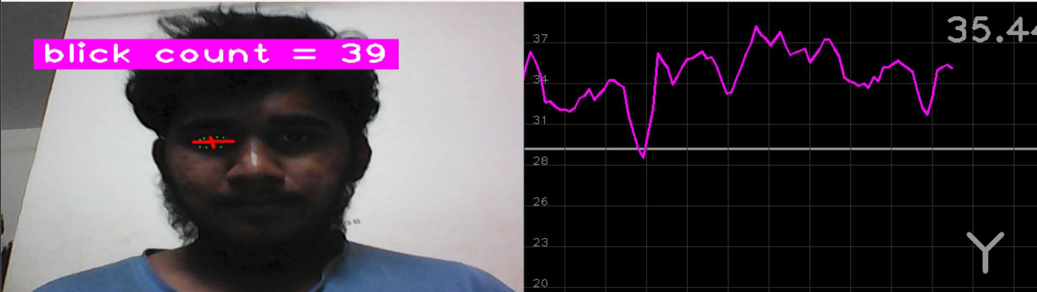

***Landmark Identification***

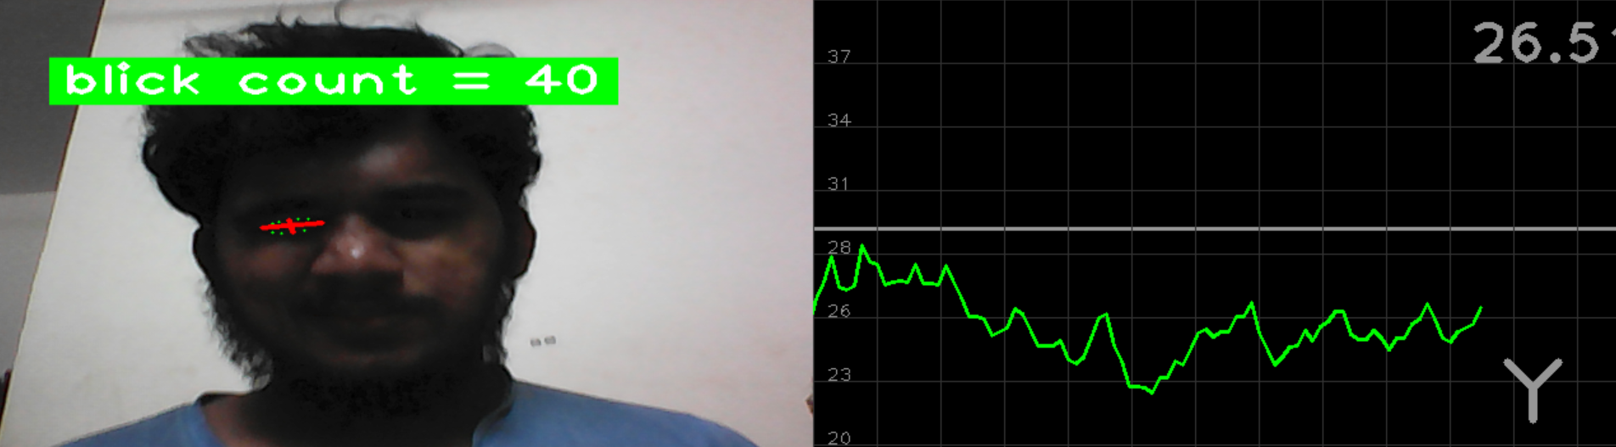

***Eye Blink Detection***

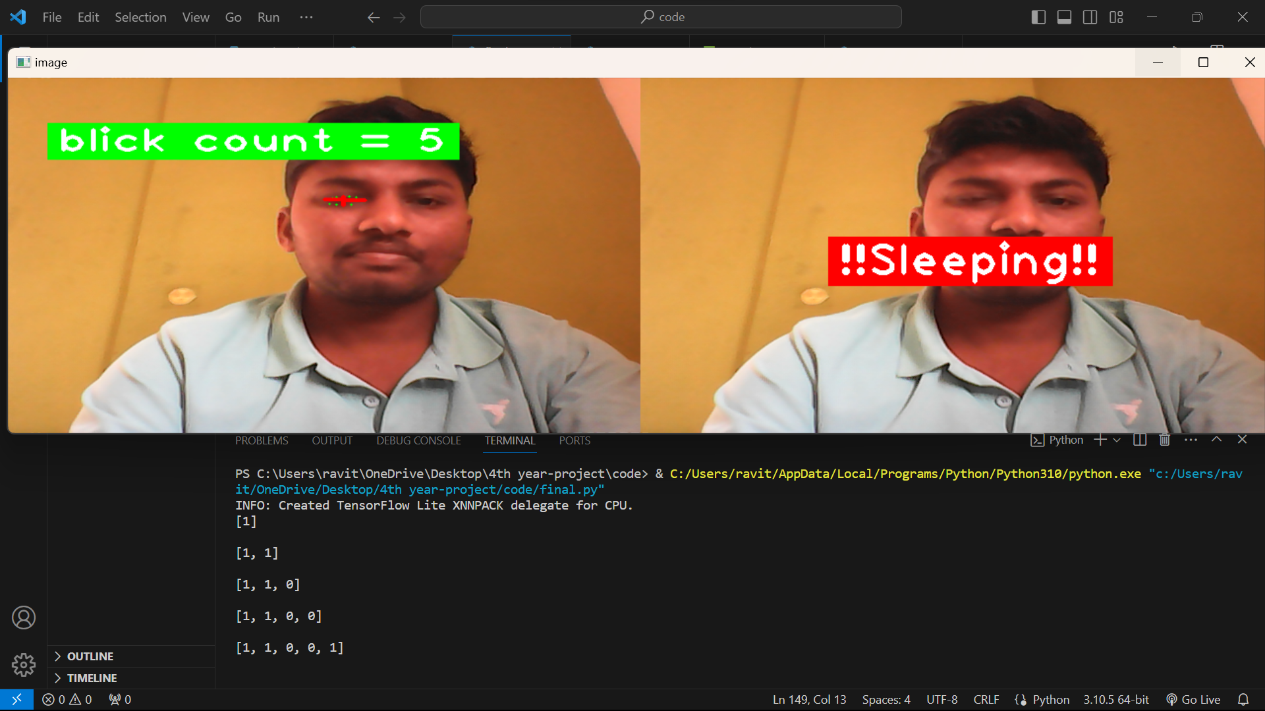

***Drowsiness Detection***



***Face Detection***

**APPENDIX-C**

**ENCLOSURES**

* Research paper is submitted in **IRJMETS – International Research Journal of Modernization in Engineering Technology and Science**
* Paper got accepted by **IRJMETS.**
* Paper id: **IRJMETS51200105456**